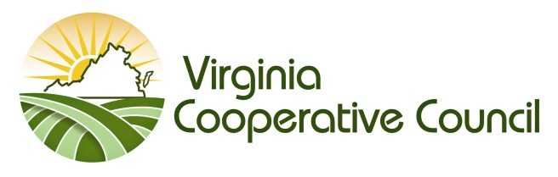

Scroggs/Raper Scholarship Application
For currently enrolled undergraduates in the Department of Agricultural & Applied Economics only
Due February 12, 2018

Full Name: ________________________________________________Preferred Name: __________________

School Address: ____________________________________________________________________________

_____________________________________________________________________________

Phone: ____________________ Email: ____________________

College/University: ___________________________________________ Class Year: ____________________

Overall GPA: ___________ out of ___________ In-major GPA: __________ Total credit hours ___________
(Completed, not in progress)

College honors/awards: _____________________________________________________________________

__________________________________________________________________________________________

__________________________________________________________________________________________

College-level leadership positions held: _________________________________________________________

__________________________________________________________________________________________

College extracurricular activities: ______________________________________________________________

__________________________________________________________________________________________

__________________________________________________________________________________________

Volunteer/community service since in college: ___________________________________________________

__________________________________________________________________________________________

__________________________________________________________________________________________

Work experience: __________________________________________________________________________

__________________________________________________________________________________________

__________________________________________________________________________________________

In 150 words or less, indicate how cooperatives have impacted the Commonwealth of Virginia:

Optional (answer only if they apply):

If you participated in the Youth Leadership Conference (now known as the Virginia Institute on Cooperative Education) sponsored by the Virginia Cooperative Council, what was the most beneficial aspect of the conference?

If you participated in the National Institute on Cooperative Education, what was the most beneficial aspect of the conference?

If you have taken a course with any cooperative content, what was the course, and what was the most interesting thing you learned?

Would you have any interest in assisting with a state or national youth leadership conference on cooperatives? If yes, why, and what skills would you bring to the conference?

What else would you like to tell us about yourself?

Return completed application to: allen.melton@sscoop.com

